# Kasturi Assist– Product Documentation

## Introduction

**Kasturi Assist** is a comprehensive **incident, service request, and asset management platform** developed by **Megamax Services Pvt. Ltd**. It is designed to streamline how organizations manage client complaints, service requests, assets, and engineers through a unified digital platform.

The system allows companies to handle incidents efficiently by automatically generating tickets from customer emails, assigning them to engineers, and tracking them until resolution. By integrating incident management with asset tracking, purchase orders, and service-level agreements (SLAs), Kasturi Assist ensures transparency, accountability, and faster issue resolution.

## Purpose of the Product

The purpose of Kasturi Assist is to:

* Provide organizations with a **centralized platform** for managing customer support and service operations.
* Reduce delays in issue resolution through **automated ticket generation and assignment**.
* Enable **real-time tracking of incidents, assets, and service requests**.
* Enhance customer experience by offering transparent communication and faster response times.
* Support businesses in meeting **SLA commitments** with detailed monitoring and reporting tools.

## Target Users

Kasturi Assist is intended for:

* **Service-based organizations** managing customer complaints and technical incidents.
* **IT and infrastructure service providers** offering AMC (Annual Maintenance Contract) or managed services.
* **Store and asset managers** who need to maintain records of parts, equipment, and associated purchase orders.
* **Engineers and technical teams** responsible for resolving customer issues.
* **Clients/Customers** who want a transparent system to log and track their issues.

## Key Highlights

* **Role-based Access Control** with distinct logins for Super Admins, Store Managers, Kasturi Assist Executives, Engineers, and Customers.
* **Incident & Service Request Management** to log, assign, and resolve issues with SLA compliance tracking.
* **Email-to-Ticket Automation** allowing customer complaints to generate incidents automatically.
* **Asset & Purchase Order Management** integrated with incident tracking.
* **Dashboards & Reports** providing SLA performance insights, incident classifications, and escalation tracking.
* **Scalable Architecture** that supports multiple companies, locations, and engineers under one platform.

## Specific Features Update

Following are the major features of the Kasturi Assist:

### Dashboard

The **Dashboard** is the central hub of the Kasturi Assist application, designed to provide a **real-time overview** of incidents, service requests, calls, and SLA compliance. It gives administrators and managers quick visibility into operational performance, pending workloads, and productivity metrics.

**Key Components**

1. Helps in identifying trends, workloads, and recurring issue patterns.
2. **Call Summary**  
   Provides quick insights into overall call activities, including:

* Calls received per month
* Calls closed per month
* Total over all closed calls
* Calls received on a day
* Pending calls a day
* Total calls pending for spare
* Productivity
* Custom Metrics

1. **Call Ageing Summary**  
   Categorizes and highlights overdue incidents, like pending calls data. This ensures SLA risks are visible and can be escalated before breach.

**Benefits of the Dashboard Section**

* At-a-glance monitoring of company-wide incidents and service requests.
* Proactive SLA management through ageing analysis and SLA breach tracking.
* Informed decision-making with real-time metrics and classification.
* Improved productivity by identifying bottlenecks (e.g., spares, vendor dependency).

### My Company

The **My Company** section allows an organization to maintain and update its official profile details within the Kasturi Assist system. This ensures accurate identification, invoicing, and communication between the company, its employees, and clients.

**Key Features**

1. **Company Information**

* Company Name
* CIN (Corporate Identification Number)
* GST Number
* Invoice Prefix

1. **Primary Contact Details**

* Contact Person
* Designation
* Contact Number
* Email Address

1. **Company Locations**

* Users can add multiple company details.
* **Add/Modify Locations** option allows expansion for organizations with multiple branches.
* Each location is uniquely identified by the **City** to avoid duplication.
* Only the **Super Admin** has permission to add unlimited locations.

1. **Address Management**

* Street/Building details for precise location reference.
* Search and Select Pin Code functionality ensures accuracy of region mapping.

1. **Listing of Saved Locations**
   * Displays a table of all registered locations with columns for:
     + Contact Person
     + Contact Number
     + Email
     + Address
   * Supports pagination for handling multiple records.

**Benefits**

* Provides a central repository of company and branch details.
* Ensures accurate invoicing and client communication.
* Supports multi-location companies by allowing multiple offices to be managed under one profile.
* Prevents duplication by enforcing unique location validation based on city.

### Master

The **Master Data Entry** module allows administrators to define and manage the foundational data sets used across the Call Board application. These master records ensure consistency, standardization, and easy configuration of the system.

**Key Features**

1. **Configurable Categories**  
   Admins can manage different master-level data types, including:

* **Pincode / City / State** – Define and map geographical details for clients and locations.
* **Skill** – Maintain a list of technical and functional skills (e.g., L1, L2, L3, SME, SQL Server, Javascript).
* **Designation** – Define employee roles and designations (e.g., System Engineer, Service Delivery Manager).
* **Domain** – Manage IT/asset domains (e.g., Network, Security, UNIX, Server, Storage, End User, Others).
* **User Type** – Create role types for access control (e.g., Super Admin, Engineer, Store Manager).

1. **User & Access Management**

* **Create/Modify User** – Add or update system users based on roles.
* **Set User Rights** – Configure permissions for different user types.
* **Resolver Group** – Define groups of engineers/teams for faster ticket resolution.

1. **Skill Management**

* Add, edit, or delete skills required for handling incidents and service requests.
* Skills are mapped to employees/engineers for better task assignment.
* Provides search and filter options for quick lookup.

1. **Edit & Delete Options**

* Each master record can be updated or removed as needed.
* The system prevents deletion if the record is already in use (for example, a skill assigned to an engineer).

**Benefits**

* Ensures **uniform data across modules** (e.g., the same city name or skill is used everywhere).
* Provides **flexibility to customize** the system as per company needs.
* Improves **incident allocation** by mapping engineers with the right skills and domains.
* Simplifies **user rights management** with clear segregation of roles.

--------------------------------------------------

### **Employee Management**

The Employee Management module in Kasturi Assist allows administrators to maintain a comprehensive database of all employees, including engineers, store managers, and other team members. This centralized database is crucial for assigning tickets, managing access, and ensuring that the right person is assigned to the right task based on their skills and designation.

**Key Features**

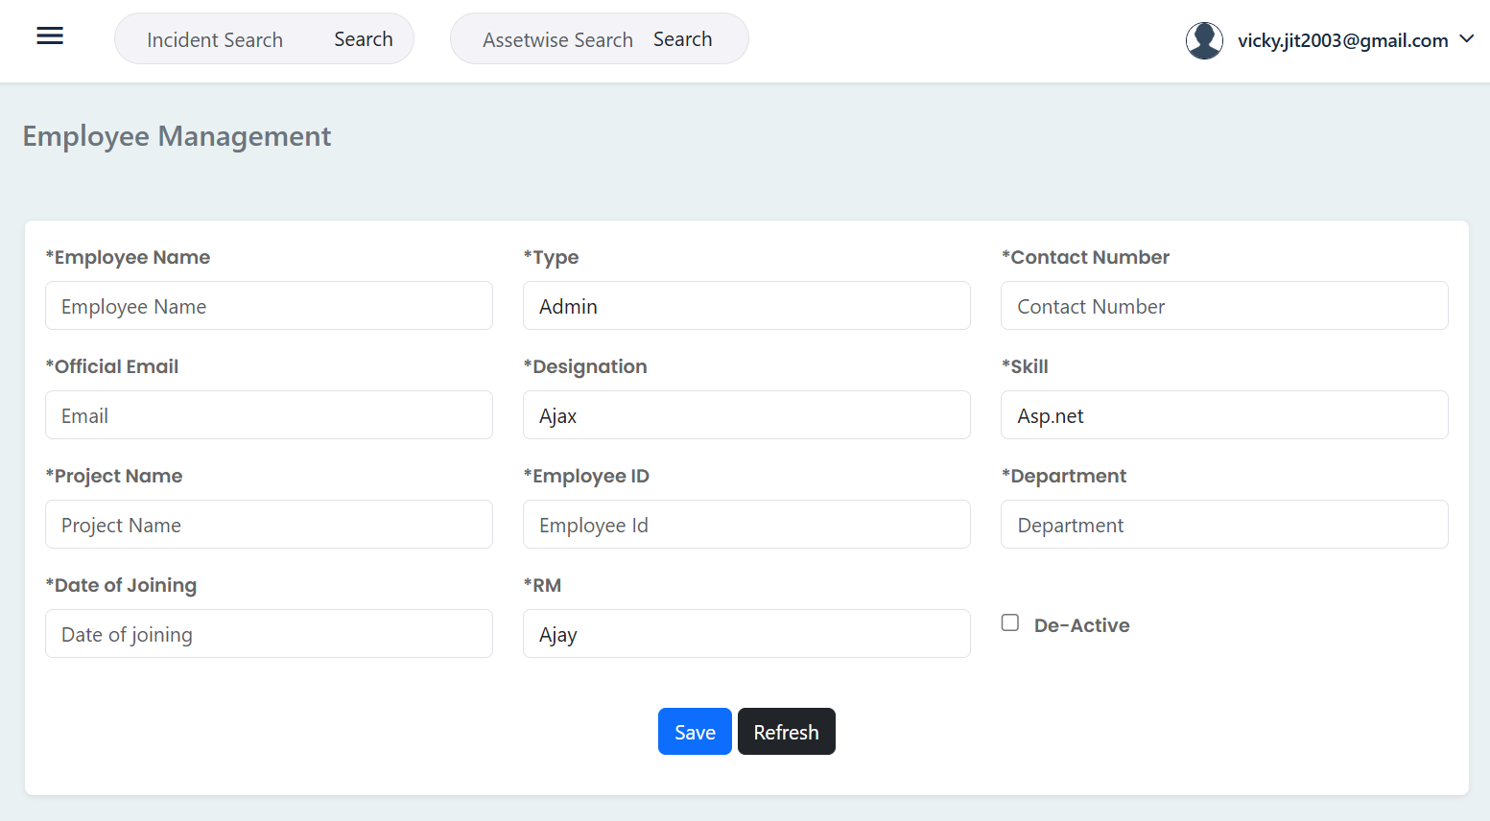

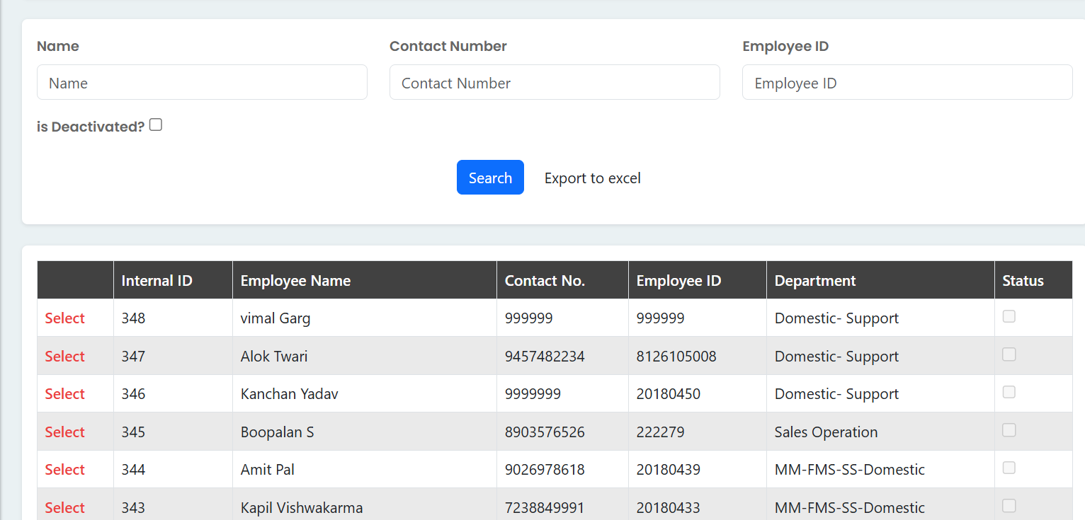

* **Employee Profile Creation:** Admins can create new employee profiles by entering key details such as:
  + Employee Name
  + Official Email
  + Contact Number
  + Employee ID
  + Designation
  + Skill (mapped from the Master data)
  + Type (e.g., Admin, Engineer, etc.)
  + Project Name
  + Department
  + Date of Joining
  + RM (Reporting Manager)
* **Skill Mapping:** Each employee can be mapped to one or more skills (e.g., L1, L2, L3 Support, SQL Server, etc.) which are pre-defined in the Master module. This mapping is vital for the automated ticket assignment feature, ensuring tickets are routed to the most qualified engineer.
* **User Status Management:** The module allows administrators to **De-Activate** an employee's account. This is useful for managing accounts of employees who have left the company, ensuring their system access is immediately revoked.
* **Search and Filter:** The search functionality enables quick lookup of employees based on their **Name**, **Contact Number**, or **Employee ID**. The list view also allows filtering for **Deactivated** accounts.
* **Data Export:** The system provides an **Export to excel** option, allowing administrators to download a complete list of employee data for reporting or record-keeping purposes.

**Benefits**

* Centralized Database
* Efficient Ticket Assignment
* Streamlined Access Control
* Improved Productivity

---------------------------------

### **Asset Management**

The Asset Management module in Kasturi Assist provides a structured and detailed way for organizations to track and manage their physical and digital assets. It integrates various aspects of an asset's lifecycle, from financial and contractual details to maintenance and disposal, ensuring complete visibility and control.

**Key Features**

The module is organized into multiple tabs, each focusing on a specific aspect of asset management:

**General:** This is the primary tab for defining the core identity and characteristics of an asset. It captures essential details that are used for tracking and management throughout the asset's lifecycle.

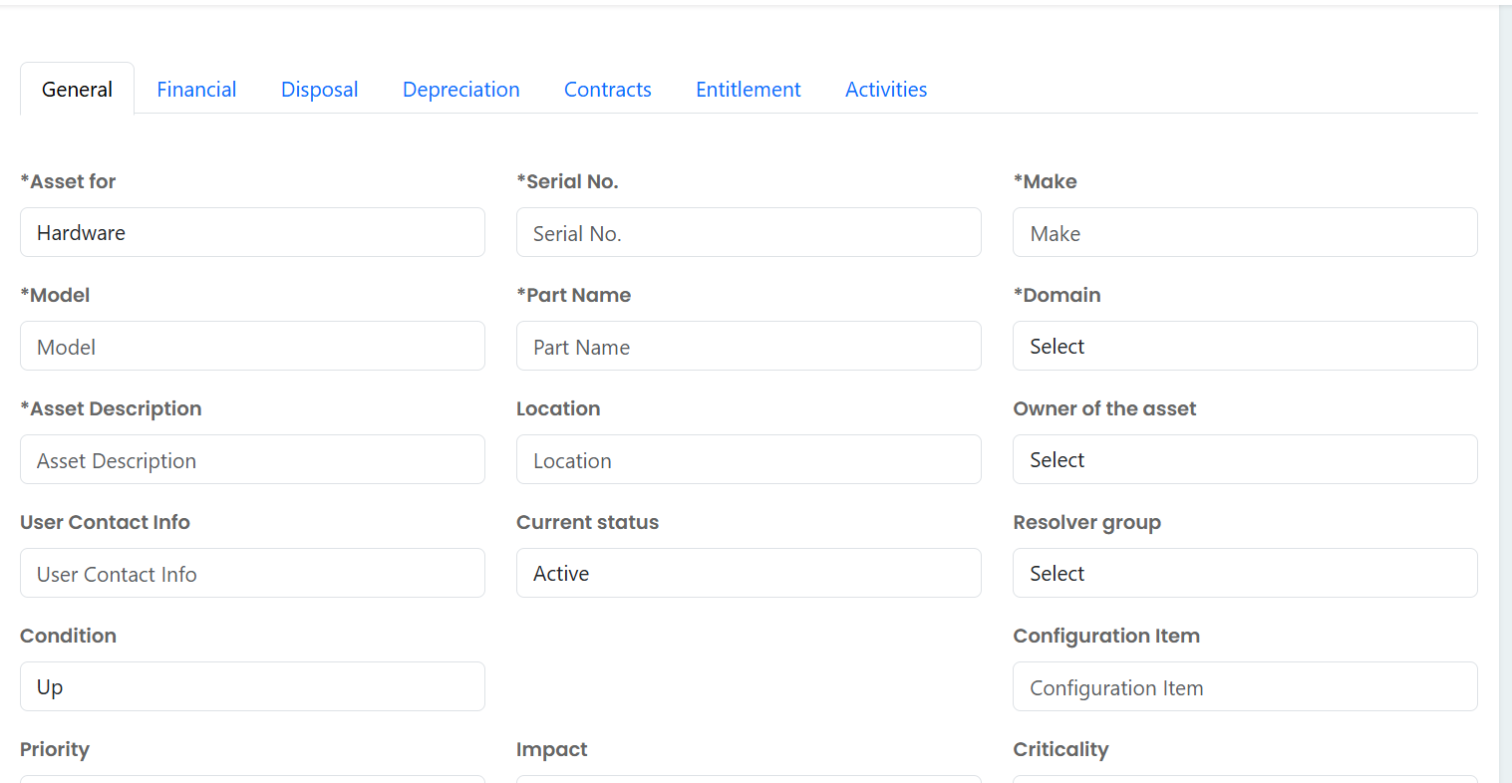

* **Basic Information:** Records key identifiers like Serial No., Make, Model, and Part Name.
* **Asset Classification:** Categorizes the asset with fields such as Asset for (e.g., Hardware), Domain, Condition (e.g., Up), Priority, Impact, and Criticality. These classifications are crucial for incident management and service level agreements.
* **Ownership & Location:** Defines the Location of the asset and the Owner of the asset, ensuring accountability.
* **Status and Support:** Tracks the Current status of the asset (e.g., Active) and links it to the appropriate Resolver group and User Contact Info for support purposes.
* **Asset Description:** A dedicated field (Asset Description) to provide a detailed overview of the asset's purpose and specifications.
* **Risk & Audit:** Records the **Risk_Level** and provides fields to track the **Last Audit Date** and **Next Schedule Audit**, which is crucial for compliance and maintenance planning.

**Financial:** This section captures the financial details of an asset.

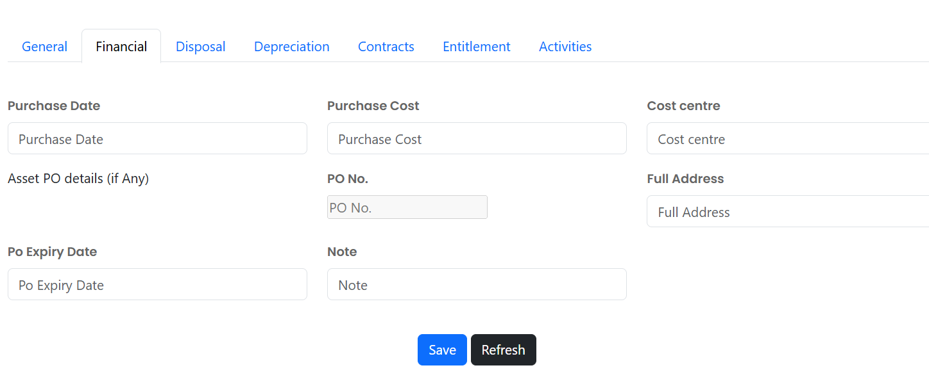

* + **Purchase Date & Cost:** Records when the asset was acquired and its initial cost.
  + **Purchase Order Details:** Allows linking the asset to a specific purchase order number (PO No.) and its expiry date (Po Expiry Date).
  + **Cost Centre:** Facilitates the allocation of asset costs to a specific department or budget.
* **Disposal:** This tab is dedicated to documenting the end-of-life process for an asset.

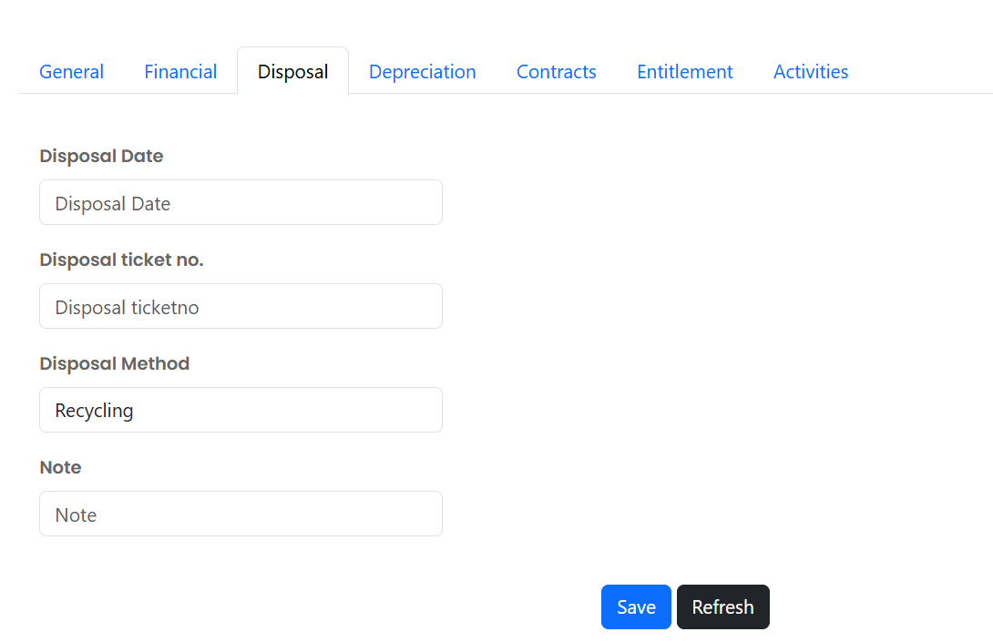

* + **Disposal Date & Method:** Records when and how an asset was disposed of (e.g., Recycling).
  + **Disposal Ticket No.:** Provides a reference number for the disposal event.
* **Depreciation:** This section helps in tracking the decrease in the value of an asset over time.

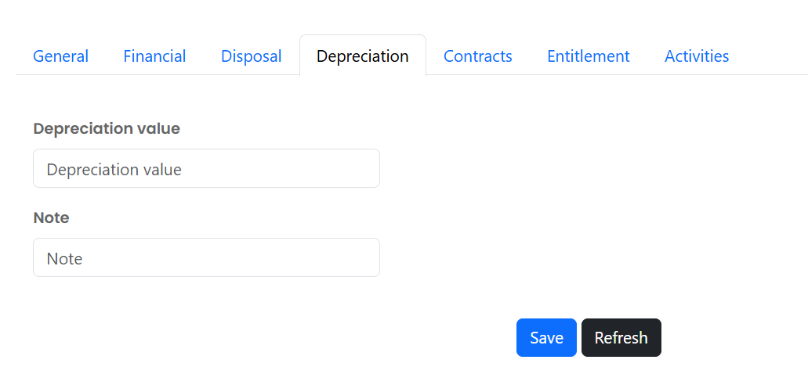

* + **Depreciation Value:** Allows for the entry of the asset's current depreciation value.
  + **Notes:** A field to add any relevant notes regarding the depreciation.
* **Contracts:** This tab manages the contractual agreements tied to the asset.

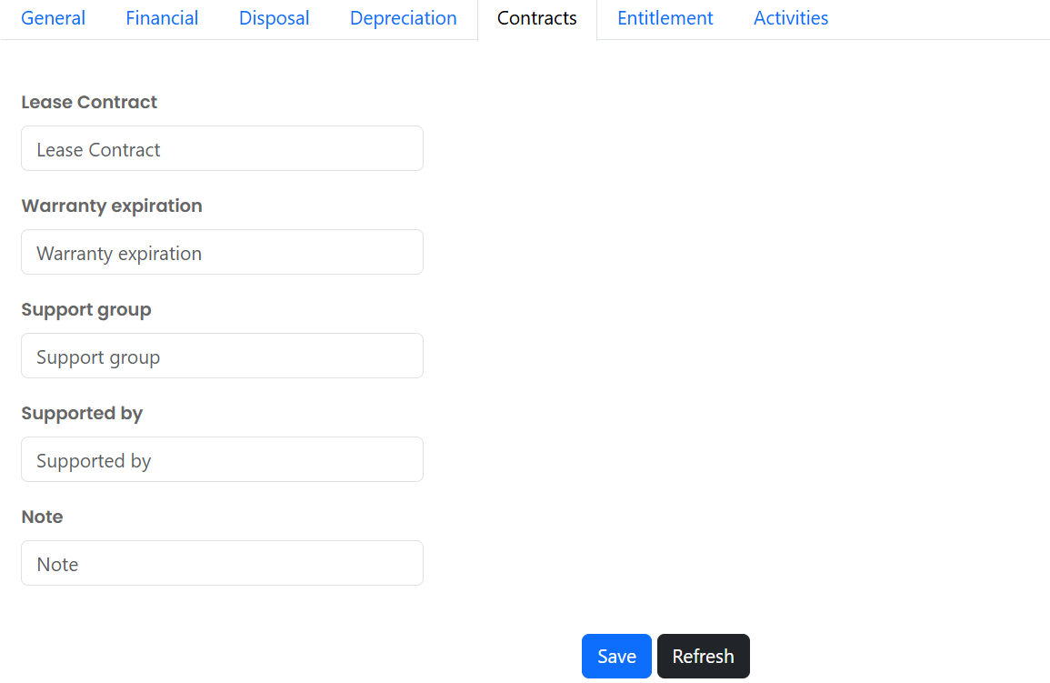

* + **Lease Contract:** Details of any lease agreement associated with the asset.
  + **Warranty Expiration:** Tracks the warranty period to ensure timely maintenance or replacement.
  + **Support Group & Supported by:** Defines which team or individual is responsible for providing support for the asset.
* **Activities:** This section provides a complete history and schedule of all asset-related events.

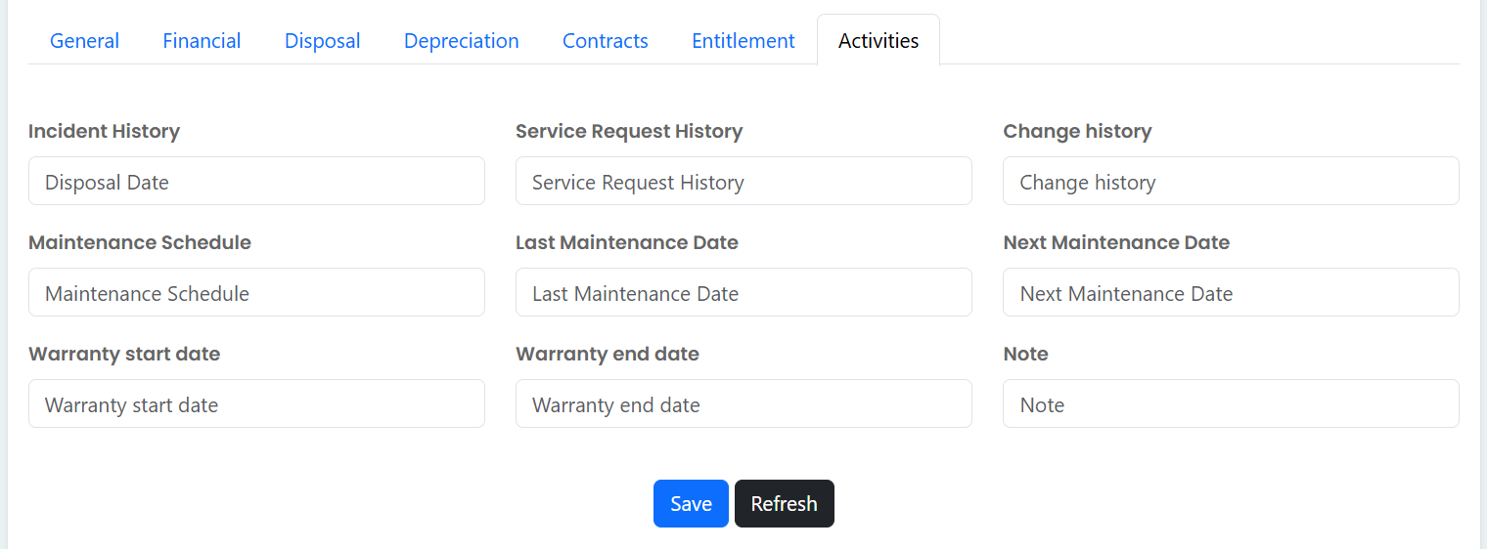

* + **History:** Tracks the asset's **Incident History** and **Service Request History**, linking it directly to the platform's core functions.
  + **Maintenance:** Records the **Last Maintenance Date** and schedules the **Next Maintenance Date**.
  + **Warranty:** Tracks the **Warranty start date** and **Warranty end date**, complementing the warranty expiration field in the Contracts tab.

**Benefits**

* **Holistic Asset View:** Provides a 360-degree view of an asset, from its purchase to its disposal, including all financial, contractual, and service-related information.
* **Integrated Incident Management:** Seamlessly links assets with incidents and service requests, providing a full history of issues and resolutions.
* **Proactive Management:** Allows for proactive planning of maintenance and contract renewals by tracking key dates like warranty expiration and next maintenance date.
* **Financial Accountability:** Captures crucial financial data like purchase cost and depreciation, which is vital for cost tracking and financial reporting.

----------------------------